Gymnosperms are one of two major groups of seed bearing plants and trees. The other group is the angiosperms, which are the flowering trees and plants. The name gymnosperm means ‘naked seed’. Conifers, ginkgoes, and cycads are all different kinds of gymnosperms. Unlike the angiosperms, the gymnosperms were around before the dinosaurs. Gymnosperms include some of the oldest and largest trees alive today such as the bristlecone pines and the giant redwoods of California.
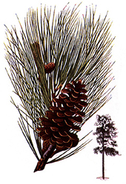 | Conifers  Conifers are the woody evergreen trees like pine, fir, cedar, hemlock, and spruce. Conifer means ‘cone bearing’. The cones are divided into male and female cones. The male cones, which are usually much smaller, produce pollen that is carried by the wind to the larger female cones. A seed is eventually formed in the female cone, which drops to the ground and produces a sapling. Most conifers are monoecious, which mean each tree produces both male and female cones.
Cycads  These palm-like trees are not palms at all. They are much older. They were the predominant vegetation during the age of the dinosaurs, many of which probably ate cycads. Today, they are mostly found in hot tropical areas. The decline of cycads worldwide was probably the result of competition with the angiosperms, which evolved during the |  | 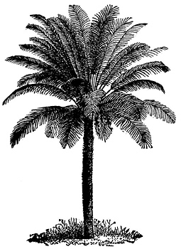
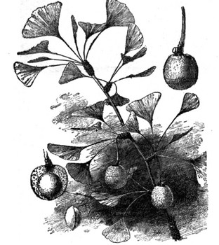 | Ginkgoes  The ginkgo tree is a ‘living fossil’. It has remained virtually unchanged for millions of years. Fossilized gingko leaves look nearly identical to modern ginkgo leaves. Only one species of gingko tree exists today. The ginkgo is dioecious, which means the trees are either male or female. Since it is resistant to pollution, the gingko tree is popular among city landscapers, but only the male tree because the seeds on the female tree contain the rancid smelling butyric acid.

